4.2 The A* Pathfinding Algorithm
Once a robot has a map of its environment, it still faces an important challenge:
How can the robot find the best route from its current location to its destination?
One of the most widely used solutions in robotics and computer science is the A* (A-Star) Pathfinding Algorithm.
A* is an informed search algorithm, meaning it uses information about the goal to intelligently prioritize which locations to explore. Unlike simpler search algorithms that may examine many unnecessary paths, A* uses a heuristic estimate to focus its search toward the destination.
Because of its efficiency and reliability, A* is commonly used in:
- Robotics
- Autonomous vehicles
- Warehouse automation
- Video games
- GPS navigation systems
- Drone navigation

How A* Works
A* finds the shortest path by assigning each node a score:
$$f(n)=g(n)+h(n)$$
where:

g(n): Path Cost
The exact cost of traveling from the start node to the current node.
Start → A → B → Current Node
The farther the robot has traveled, the larger the value of $g(n)$.

h(n): Heuristic Cost
The heuristic estimates the remaining distance to the goal.
Think of it as the robot asking:
"How far do I still have left to travel?"
The heuristic is not the actual distance—it is an estimate.

f(n): Total Cost
The total score combines:
Cost Already Traveled
+
Estimated Cost Remaining
The A* algorithm repeatedly explores the node with the smallest $f(n)$value.
This allows the robot to balance:
- Progress already made
- Estimated progress remaining

Manhattan Distance Heuristic
For occupancy grids where robots can move only:
- North
- South
- East
- West
The most common heuristic is the Manhattan Distance.
$$h(n)=∣x_goal-x_n∣+∣y_goal-y_n∣$$
This is called Manhattan Distance because it resembles moving through a city street grid where diagonal movement is not allowed.

Example
Suppose:
Current Node = (2,1)

Goal Node = (5,4)
Then:
$$h(n)=∣5-2∣+∣4-1∣ \\ h(n)=3+3 \\ h(n)=6$$
The estimated distance to the goal is 6 grid cells.

A* Example on a Grid
Consider this map:
S = Start
G = Goal
X = Obstacle

S . . . .
. X X . .
. . . . .
. . X . G
The robot begins at S and wants to reach G.
Instead of exploring every possible route, A* prioritizes cells that:
- Move toward the goal
- Avoid obstacles
- Minimize overall travel distance
The result is an efficient shortest path.

VEX AIM Example: Classroom Navigation
Suppose a VEX AIM robot is tasked with delivering a marker to the opposite side of a classroom.

Occupancy Grid
□ □ □ □ G
□ ■ ■ □ □
□ □ □ □ □
□ □ ■ □ □
S □ □ □ □
Where:
- □ = Free space
- ■ = Desk
- S = Robot
- G = Goal

What A* Does
The AIM robot:
- Builds an occupancy grid using sensors.
- Calculates $g(n)$for explored cells.
- Uses Manhattan Distance to estimate $h(n)$.
- Evaluates $f(n)$.
- Selects the path with the lowest overall cost.
Instead of wandering around the classroom, the robot quickly identifies the shortest route around the desks.

VEX AIM Example: Collecting a Game Object
Imagine a VEX AIM robot competing in a challenge field.
The robot must:
- Start at a home zone.
- Navigate around walls.
- Reach a game object.
Using A*:
Home Zone → Goal Object*
the robot evaluates various possible routes and chooses the path with the lowest total cost.
If a barrier blocks the direct route, A* automatically finds an alternate path.
This strategy is much more efficient than reactive navigation alone.

Real-World Example 1: Warehouse Robots
Companies such as Amazon operate thousands of autonomous warehouse robots.
Warehouse maps contain:
- Shelving units
- Loading stations
- Pick-up locations
The robots use graph representations similar to occupancy grids.
A* helps determine:
- The shortest route to inventory
- Efficient travel around obstacles
- Quick delivery paths
Without path planning, robots would waste time wandering through aisles.

Real-World Example 2: Robotic Vacuum Cleaners
Modern robotic vacuums often create maps of homes.
Suppose the charging station is located on the opposite side of the house.
Instead of moving randomly, the vacuum can:
- Build an occupancy grid.
- Locate the charging dock.
- Calculate the shortest path.
A* allows the vacuum to efficiently return for charging while avoiding furniture.

Real-World Example 3: GPS Navigation Systems
GPS navigation uses concepts similar to A*.
When you request directions:
Current Location → Destin*tion
the navigation software searches a massive transportation graph.
Roads become edges.
Intersections become nodes.
The route calculation balances:
- Distance
- Travel time
- Road restrictions
Although modern GPS systems use more advanced variations, the underlying principles are similar to A*.

Real-World Example 4: Autonomous Vehicles
Self-driving vehicles continuously plan routes through road networks.
The vehicle must find paths that avoid:
- Road closures
- Construction zones
- Traffic congestion
Path-planning algorithms related to A* help determine safe and efficient routes from one location to another.

Advantages of A*
✅ Finds the shortest path
✅ Efficient compared to uninformed search algorithms
✅ Works well with occupancy grids
✅ Easy to implement
✅ Widely used in robotics

Limitations of A*
❌ Large maps require more memory
❌ Performance decreases as maps become larger
❌ Requires a good heuristic
❌ Dynamic environments may require repeated replanning

Multiple-Choice Question
A VEX AIM robot is navigating a classroom represented as an occupancy grid. Which value does A* use to estimate the remaining distance from the robot's current location to the goal?
A. $g(n)$
B. $h(n)$✅
C. $f(n)$
D. $L$
Correct Answer: B

Explanation
The heuristic cost $h(n)$estimates how far the robot is from the goal. In grid-based environments, this is often calculated using Manhattan Distance.

Multiple-Choice Question
Which statement best describes why A* is more efficient than a simple exhaustive search?
A. It ignores obstacles.
B. It only explores nodes directly next to the goal.
C. It combines actual travel cost with an estimate of the remaining distance to prioritize promising paths. ✅
D. It always moves in a straight line.
Correct Answer: C

Explanation
A* uses:
$$f(n)=g(n)+h(n)$$
to prioritize nodes that appear most likely to lead to an efficient solution.

CodeLens Activity: Calculating A* Costs
Consider the following values:
g = 5 # Cost from start to current node
h = 3 # Estimated distance to goal

f = g + h

print(f)

Question
What value will be printed?
A. 2
B. 5
C. 3
D. 8 ✅
Correct Answer: D

Explanation
A* calculates:
$$f(n)=g(n)+h(n)$$
Substituting the values:
$$f(n)=5+3=8$$
The node's total score is 8.

CodeLens Activity: Manhattan Distance
Consider the following pseudocode:
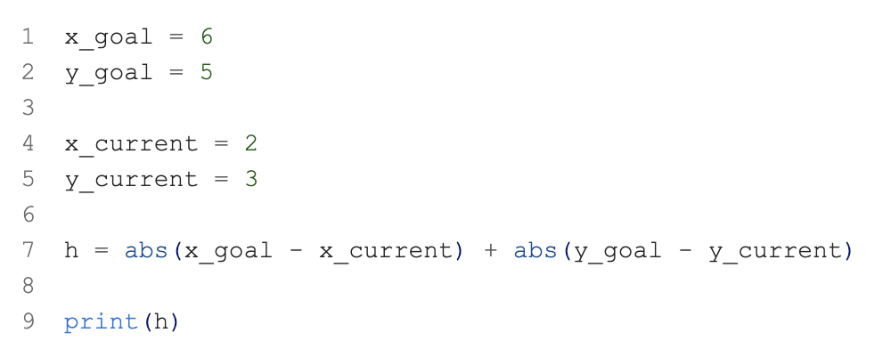

x_goal = 6
y_goal = 5

x_current = 2
y_current = 3

h = abs(x_goal - x_current) + abs(y_goal - y_current)

print(h)

Question
What Manhattan Distance will be calculated?
A. 4
B. 6 ✅
C. 8
D. 10
Correct Answer: B

Explanation
$$h=∣6-2∣+∣5-3∣ \\ h=4+2 \\ h=6$$
The heuristic estimates that the robot is 6 grid cells away from the goal.

